1. Explore Page Wireframe Explanation

Explore page is the main functionality page for the ToolNest website. It is built in such a way as to allow people to explore and interact with different digital tools.

Starting from the top, we have the header part of the page with the ToolNest logo, navigation menu items (Home, Explore, About, Contact), and a switcher for dark mode. The same header will be present on all other pages.

The next part of the page is the hero/search part. Here, the page gets introduced by the name “Explore Tools” and its description. There is also a search field where people can input their tool name to find it. Below the search bar, one may find filter buttons that allow filtering tools by category.
The following part is the Favorites part, wherein users get the chance to see their selected favorites. The advantage this has over others is that it makes it easier for them to access tools.

Afterwards comes the Tools Grid part, which consists of cards of each tool, wherein there are:

-An icon/image of the tool
-Name of the tool and short description
-Rating mechanism (star rating)
-Visit button (which takes you to the tool)

The purpose of this arrangement is to make it look good and easily scannable.

Lastly comes the Footer part, consisting of general data such as copyrighting data.

Thus, it is safe to say that the main objective of the Explore page is usability, interactivity, and effectiveness of search.

2. Contact Page Wireframe Description

The Contact page is intended to offer an easy means of reaching the ToolNest platform through straightforward communication options.

There is a header at the top of the page which follows the overall pattern of the site’s design so that users can move between pages easily.

Beneath the header is a hero section featuring the heading “Contact Us,” along with a brief explanation for the user.

Following the hero section is the Contact Options section, which features various means of contact presented in card format. Some examples of the contact options featured on the page are:

-Email
-Instagram
-Twitter
-LinkedIn

The contact options are represented as cards which include:

-A logo of the platform
-Name of the contact option
-Link/button to get access to it

In such a way, users have an opportunity to find the desired contact option easily.

Finally, there is the footer at the bottom of the web page, where users can find information about copyright issues and branding of the platform.

Thus, the page of contact options is user-friendly and easily readable.
3. Page wireframe explanation: About page

The About page is made for users to learn more about the ToolNest platform – its goal, intentions, as well as the vision for its future development.

In the upper part of the About page there is the header section that is similar to those on other pages – it includes the ToolNest logo, the navigation links (Home, Explore, About, Contact) and the dark mode toggle.

Under the header is the hero/title section featuring the page title "About ToolNest". The title provides users with information concerning the page's purpose.

After the page title comes the content section where the information about the website is written in several paragraphs. It is about:

The purpose of the website
The goals of the platform (simplify access to useful online tools)
The future vision (implement new features like user accounts, recommendations, and reviews)

Thus, the content of the page is meant to deliver information in an organized and clear way.

The footer at the bottom of the page provides some basic information such as the copyright notice.
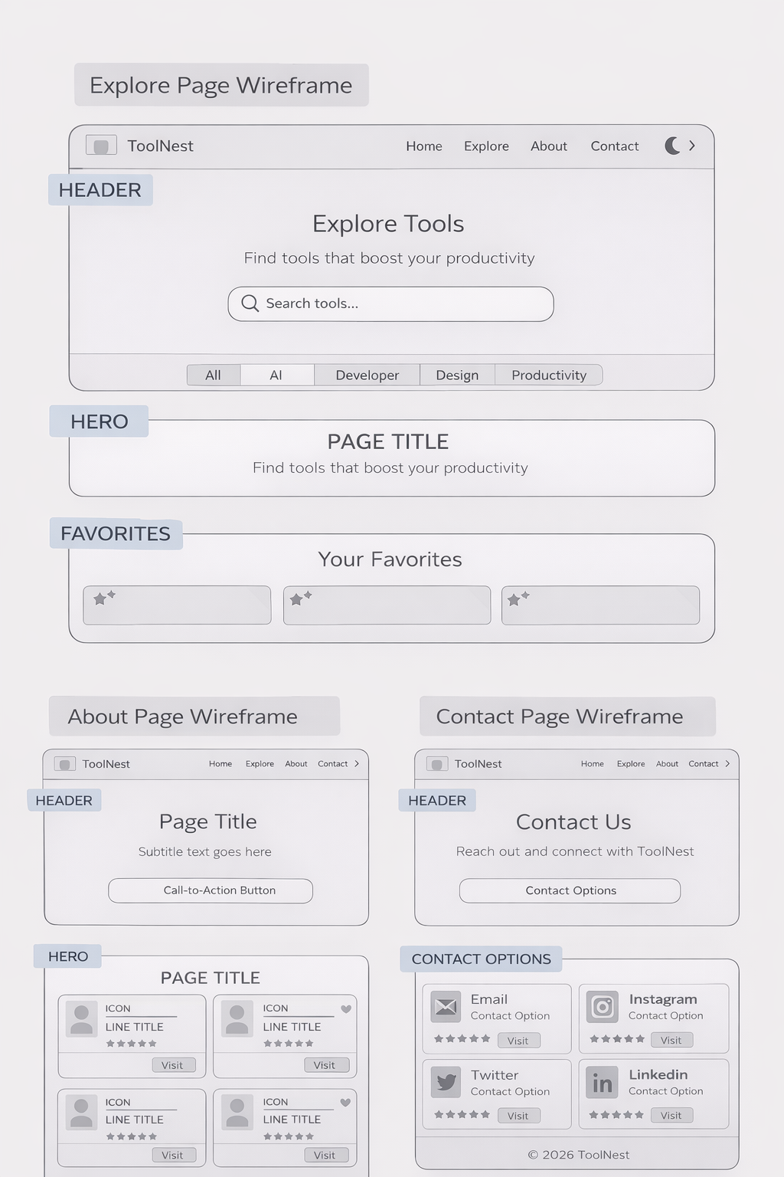
3. Wireframe Explanation for Home Page

The Home page acts as the home page of ToolNest and its aim is to provide an overview of the platform and direct users towards exploring the available tools.

In the upper portion of the page sits the header where the logo, navigational links (Home, Explore, About, Contact), and dark mode button reside to ensure a constant way of navigation throughout the site.

Further down in the middle lies the hero section, the visual highlight of the entire webpage. This section includes:

-A large title describing the platform (for example, “Discover the Best Digital Tools”)
-A brief statement about what the website is all about
-A call-to-action button such as “Explore Tools” directing the user to the Explore page

Such a design helps in grabbing the user’s attention right away.
After the heroes’ section is the features’ section that outlines some functionalities of the website. They are displayed in cards, and they include:

-Smart Search – where users can search for the tools
-Save Favorites – where users can save their favorite tools
-Rate Tools – where users can rate the tools

These elements will help users understand what the website is about and engage more with it.

At the very bottom part of the website is the footer, which provides some basics like the copyright notice among others.

All in all, the Home page of the website has been kept simple and attractive to users.
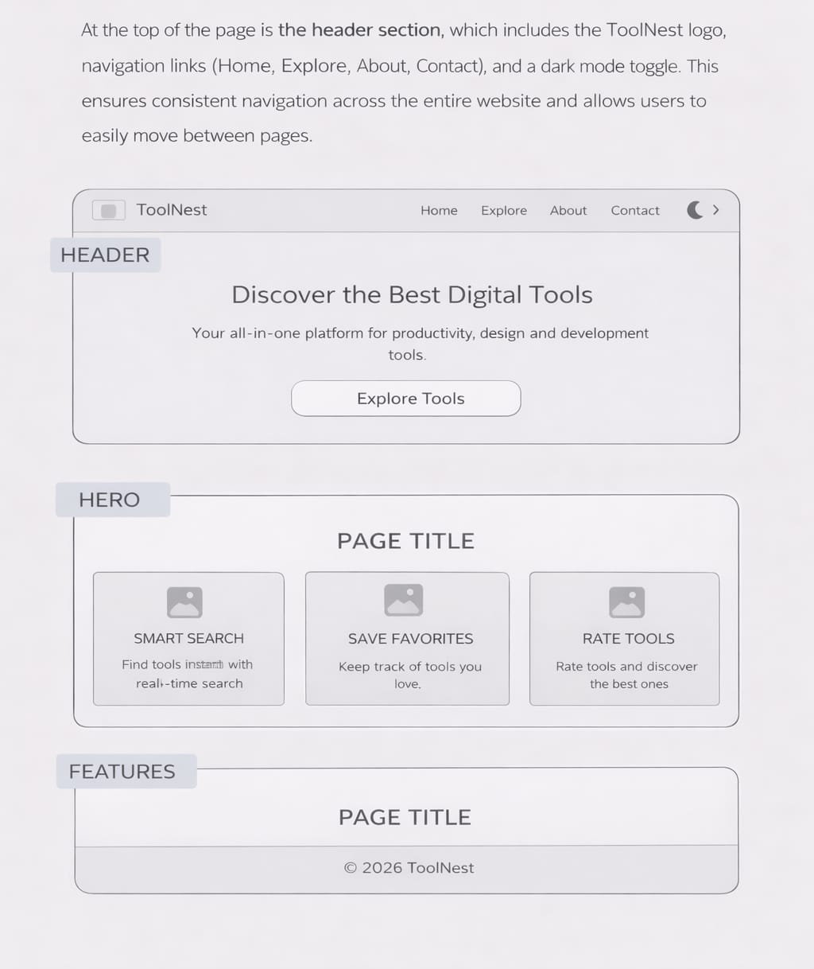
Home Page Wireframe

